**DS POINTERS LAB PRACTICALS**

NAME:Megha Patel

ROLL NO:20124107

1. C program to accept 'n' numbers from the user and sort them in ascending order using Dynamic Memory Allocation.

#include<stdio.h>

#include<stdlib.h>

int main()

{

int n,*ptr,i,t,j;

printf("how many number you want to eter for sorting in ascending order");

scanf("%d",&n);

printf("enter numers");

ptr=(int*)malloc(n*sizeof(int));

for(i=0;i<=n-1;i++)

{

scanf("%d",(ptr+i));

}

for(i=0;i<n;i++)

{

for(j=0;j<=i;j++)

{

if(*(ptr+j)>*(ptr+i))

{

t=*(ptr+i);

*(ptr+i)=*(ptr+j);

*(ptr+j)=t;

}

}

}printf("in ascemding order :");

printf("\n");

for(i=0;i<n;i++)

{

printf("%d\n",*(ptr+i));

}

}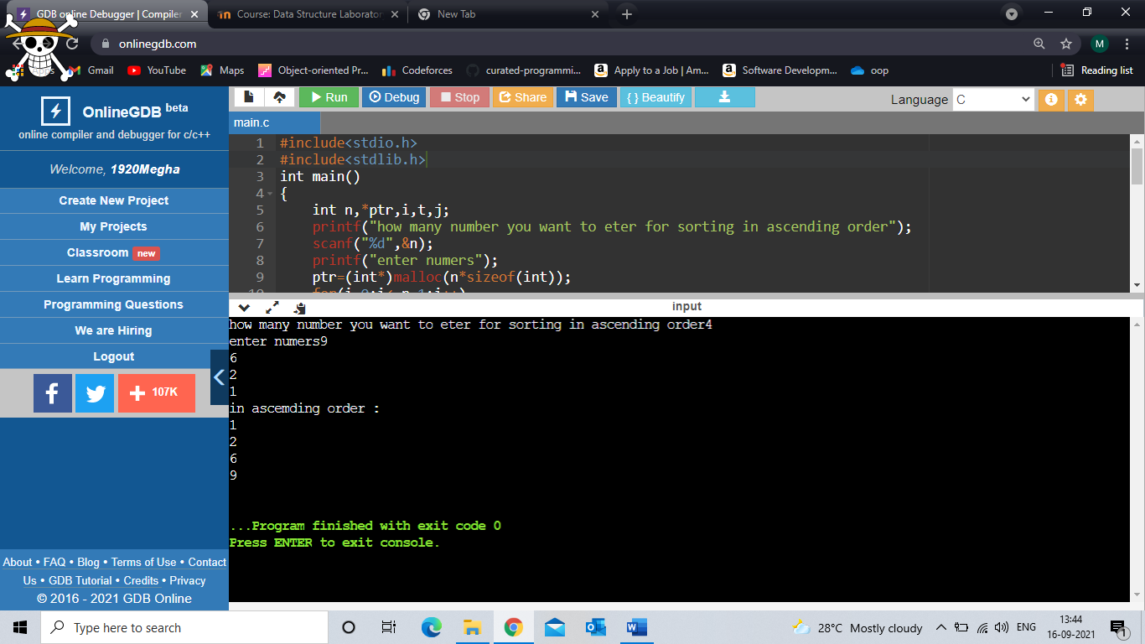

2. C program to print the elements of an array in reverse order.

#include<stdio.h>

int main()

{

int ar[50],n;

int *ptr1,i,t,j;

printf("enter number of element you want to enter");

scanf("%d",&n);

printf("now enter them\n");

ptr1=&ar[n-1];

for(i=0;i<n;i++)

{

scanf("%d",&ar[i]);

}

printf("its reverse is");

for(i=0;i<n;i++)

{

printf("\n%d",*ptr1--);

}

}

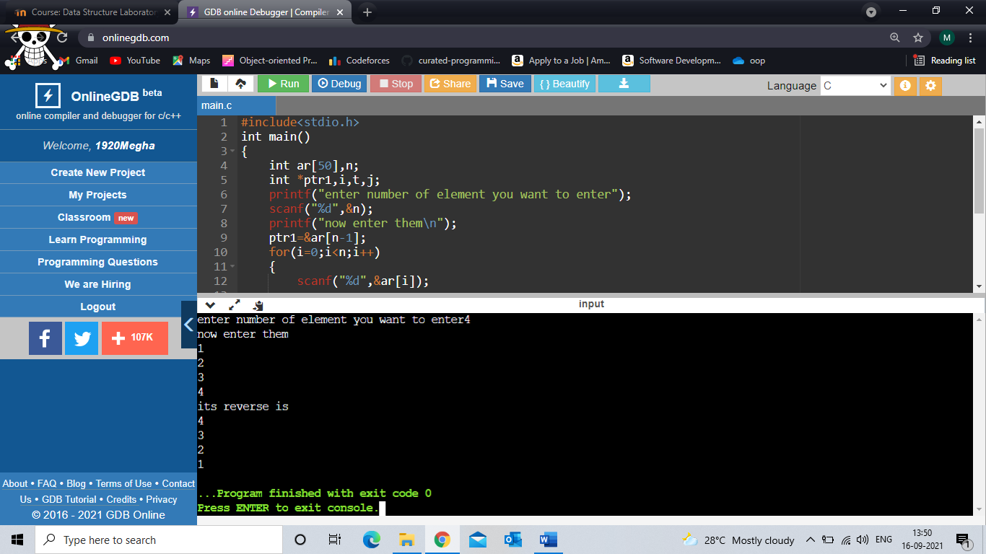

3. C program to print all the alphabets using a pointer.

#include<stdio.h>

int main()

{

int i,d,*p;

char c;

d=65;

p=&d;

for(i=0;i<=25;i++)

{

printf("%c ",*p);

*p=*p+1;

}

}

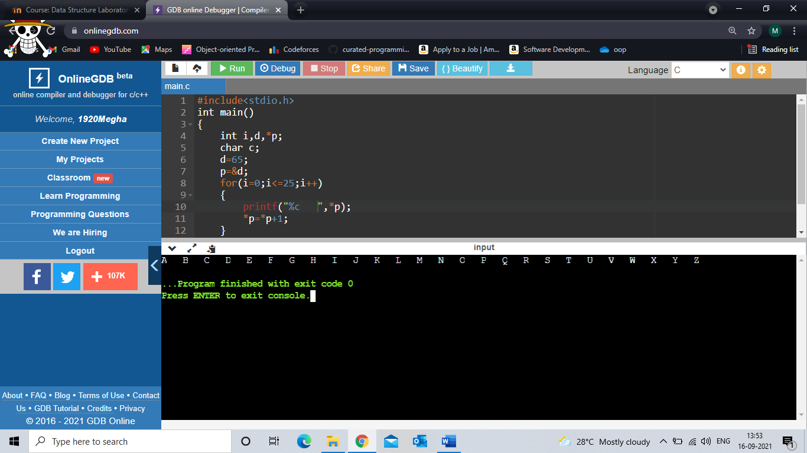

4. C program to find the smallest number using pointer.

#include<stdio.h>

void main()

{

int i,*ptr,n,a[10];

printf("how many number you want to enter?\n");

scanf("%d",&n);

printf("enter them\n");

for(i=0;i<n;i++)

{

scanf("%d",&a[i]);

}

ptr=&a[0];

for(i=1;i<n;i++)

{

if(*ptr>a[1])

{

*ptr=a[i];

}

}

printf("\nsmallest number=%d\n",*ptr);

}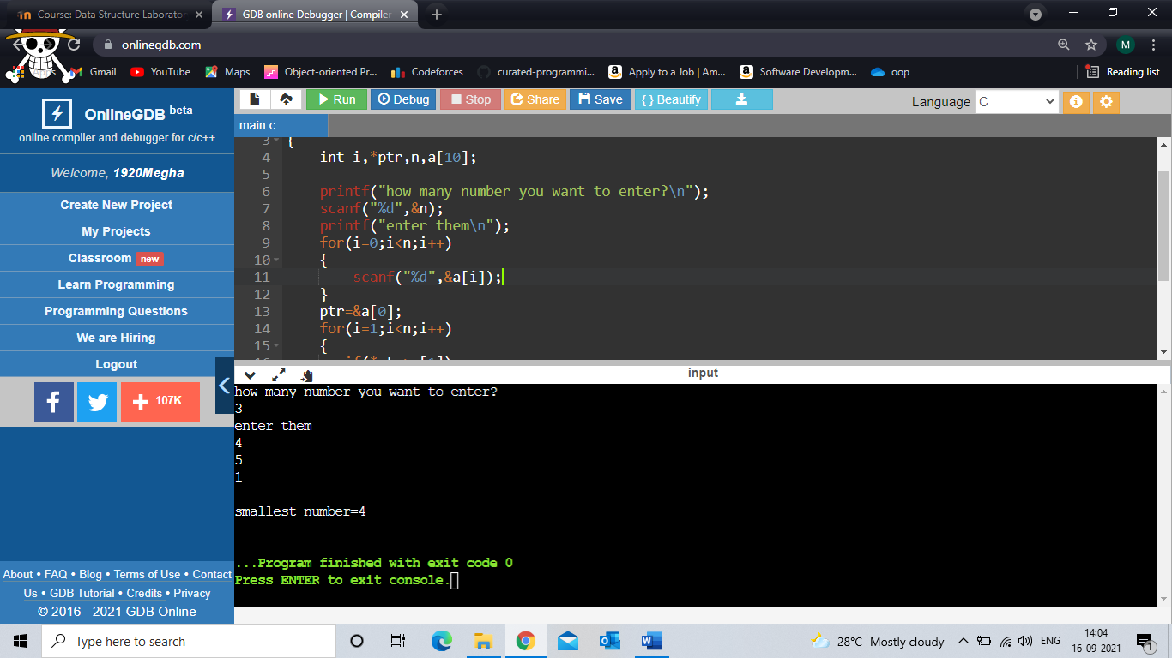

5. C program to copy one array to another using pointers.

#include<stdio.h>

void main()

{

int i,*p1,*p2,n,a1[10],a2[10];

printf("how many number you want to enter?\n");

scanf("%d",&n);

printf("enter them\n");

for(i=0;i<n;i++)

{

scanf("%d",&a1[i]);

a2[i]=NULL;

}

printf("array 2 before getting copied into\n");

for(i=0;i<n;i++)

{

printf("%d,",a2[i]);

}

p1=a2;

p2=a1;

for(i=0;i<n;i++)

{

*p1=*p2;

*p1++;

*p2++;

}

printf("\narray 2 after coping array you entered\n");

for(i=0;i<n;i++)

{

printf("%d,",a2[i]);

}}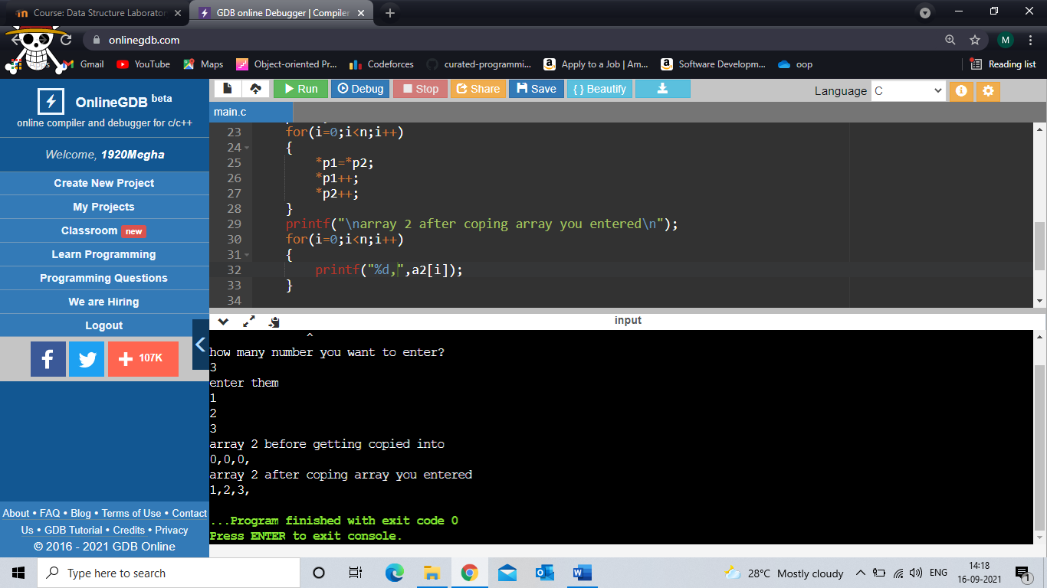

6. C program to search element in array using pointers.

#include<stdio.h>

int main()

{

int a[100],*p,i,n,j;

printf("number of array elements");

scanf("%d",&n);

printf("enter them");

for(i=0;i<n;i++)

{

scanf("%d",&a[i]);

}

printf("enter element to seach for");

scanf("%d",&j);

p=a;

for(i=0;i<n;i++)

{

if(*p==j)

{

printf("%d is found on position %d\n",j,i);

}

*p++;

}

}

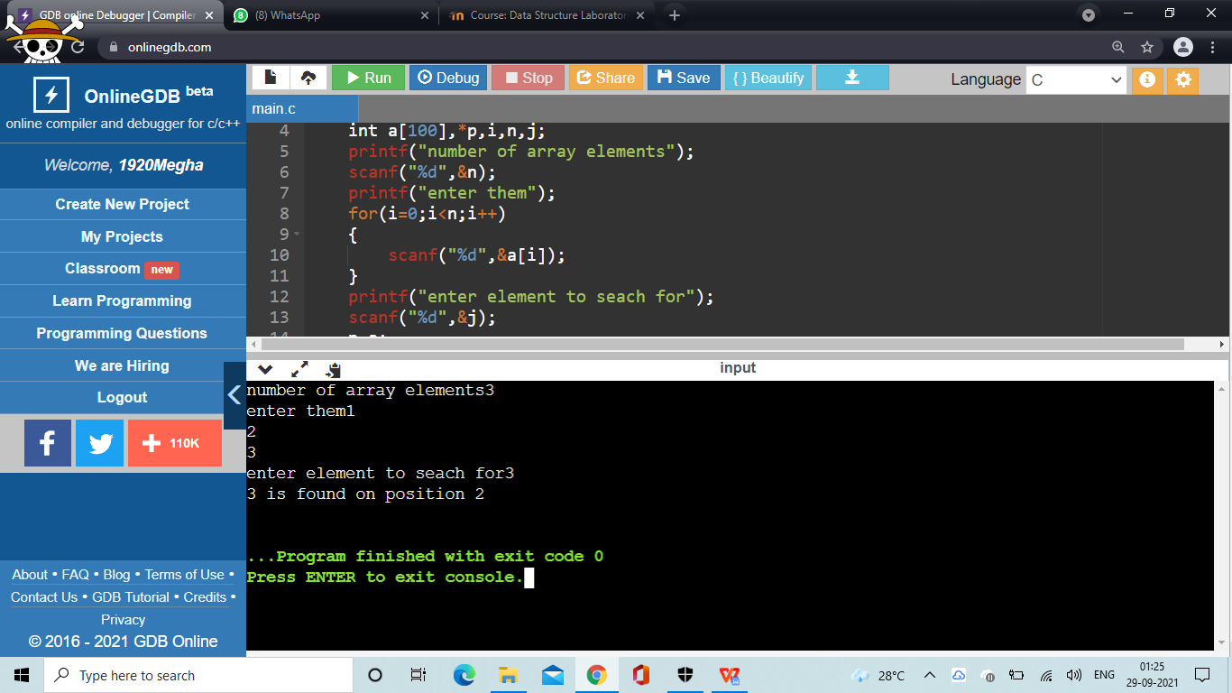

7. C program to find array sum of array elements using Dynamic Memory Allocation.

#include<stdio.h>

int sum(int size);

int main()

{

int *ptr,ar[100],n,i,s;

printf("enter the no of elements in the array\n");

scanf("%d",&n);

s=sum(n);

printf("sum is %d",s);

}

int sum(int size)

{

int sum=0,i,*ptr;

printf("enter the elements");

ptr=(int*)malloc(size*sizeof(int));

for(i=0;i<size;i++)

{

scanf("%d",(ptr+i));

}

for(i=0;i<size;i++)

{

sum=sum+*(ptr+i);

}

return sum;

}

